**WATER QUALITY PREDICTION**

Kesavan M   
*Department of CSE,*

*Rajalakshmi Engineering College*  
Chennai, India  
kesavanmurugan77@gmail.com

ABSTRACT

***Public health greatly relies on clean water, whereas urban expansion, industrial water pollution, and agricultural water pollution are deteriorating water quality. Effective forecasting of water potability is vital for community health protection as well as device management. This research focuses on the employment of machine learning (ML) algorithms to estimate the quality of water based on various physicochemical parameters: pH level, hardness, amount of solids, chloramines, sulfate, and conductivity. Machine learning algorithms can efficiently analyze historical data and make predictions in real-time. Unlike traditional lab tests that are expensive and take a lot of time, ML tests are far more efficient. With this research, water samples will be classified as potable or non-potable using the Logistic Regression, Decision Tree, Random Forest, and Support Vector Machine models. The dataset was obtained from freely accessible public repositories and underwent preprocessing by means of label encoding and normalization. The best predictive model for the data was Random Forest, while Decision Tree and SVM followed closely behind, all three displaying accuracy in predicting sources of water unfit for consumption. Moreover, machine learning proved to be effective not just for prediction, but also analyzing features where potability could be predicted, such as sulfate and pH concentration on untreatable water sources. These results support the claim that machine learning effectively detects water contamination early on, aiding both governmental and non-governmental organizations.***

# Introduction

Water that is clean and safe stands as an essential component for human well-being as well as economic expansion and environmental protection. The process of industrialization together with urban development and agricultural runoff and inadequate waste management practices have intensified water contamination issues which primarily affect developing countries including India. The daily water supply for millions of people depends on groundwater and unprocessed surface water yet the safety levels of these sources remain unknown. Water quality assessment methods from the past can achieve precision but they need laboratories together with skilled operators and high costs and the process takes too much time to perform large-scale or real-time monitoring. The difficulty of water quality monitoring increases substantially when dealing with areas that lack sufficient resources and basic infrastructure. A cost-effective and easily scalable solution needs to be developed for dependable water quality prediction and monitoring. Continuous assessment of water quality through traditional manual testing methods proves impossible because of their inability to generate predictive insights necessary for avoiding health crises due to contamination. Machine learning (ML) serves as the best solution to solve these challenges. ML demonstrates its effectiveness in environmental analysis through its capacity to understand complex patterns within extensive data sets and deliver precise predictions. Through the development of predictive models, ML technology uses historical water quality data combined with environmental information to make accurate predictions about water quality.

Literature Review

Water that is clean and safe stands as an essential component for human well-being as well as economic expansion and environmental protection. The process of industrialization together with urban development and agricultural runoff and inadequate waste management practices have intensified water contamination issues which primarily affect developing countries including India. The daily water supply for millions of people depends on groundwater and unprocessed surface water yet the safety levels of these sources remain unknown. Water quality assessment methods from the past can achieve precision but they need laboratories together with skilled operators and high costs and the process takes too much time to perform large-scale or real-time monitoring. The difficulty of water quality monitoring increases substantially when dealing with areas that lack sufficient resources and basic infrastructure. A cost-effective and easily scalable solution needs to be developed for dependable water quality prediction and monitoring. Continuous assessment of water quality through traditional manual testing methods proves impossible because of their inability to generate predictive insights necessary for avoiding health crises due to contamination. Machine learning (ML) serves as the best solution to solve these challenges. ML demonstrates its effectiveness in environmental analysis through its capacity to understand complex patterns within extensive data sets and deliver precise predictions. Through the development of predictive models, ML technology uses historical water quality data combined with environmental information to make accurate predictions about water quality. More advanced models such as decision trees, support vector machines (SVMs), and ensemble techniques like Random Forest and Gradient Boosting have demonstrated superior performance in water quality prediction tasks. Decision trees provide an easy way to categorize water quality through feature thresholds and also discover the leading factors of contamination which include high nitrate concentrations and pH abnormalities. Random Forest combines multiple decision trees to enhance generalization and protect against overfitting in studies dealing with complex or noisy data. These models demonstrate effective performance when handling numerous variables which allows them to accurately forecast water potability. The capability of SVMs to solve classification problems that are both linear and non-linear makes them a popular choice in various fields. Research demonstrates that SVMs deliver better water safety predictions than standard models when used alongside feature selection techniques for dimensionality reduction. By using these methods, the models can concentrate on the essential water quality features which leads to improved performance. The expanding use of machine learning models demonstrates an emerging trend toward data-focused flexible systems which achieve higher prediction accuracy for water quality across urban and rural environments and locations with minimal monitoring capabilities.

# Proposed methodology

The suggested method stresses the usage of different machine learning (ML) models in the prediction of India's crop yield, where this nation is known for differing agro-climatic conditions as well as differentiated agricultural trends. Crop estimation correctly is pertinent not only as support for agriculturalist decision-making, but even national food safety is ensured because right resource usage enhances the planning system in agricultural life. This research leverages supervised learning algorithms to build a robust predictive model that can generalize well across different geographical regions and crop types, thereby addressing the multifaceted challenges prevalent in traditional forecasting approaches.

*A. Data Acquisition and Preprocessing*

The first step is to gather data from various authenticated sources such as the Indian Ministry of Agriculture, Indian Meteorological Department (IMD), agricultural extension offices, and local weather stations. Datasets cover a range of years and contain attributes like average rainfall, temperature, humidity, soil pH, soil texture, crop type, previous yield history, fertilizer application, and irrigation practices. Following data collection, preprocessing is conducted to address inconsistencies, missing values, and outliers. Categorical variables (e.g., crop type, region) are encoded by label encoding and one-hot encoding methods. Continuous variables are normalized with min-max scaling to standardize them for use across algorithms, especially those that are sensitive to feature magnitude such as SVM and Linear Regression. Principal Component Analysis (PCA) is also under consideration for reducing dimensionality and removing multicollinearity amongst variables.

*B. Model Selection and Training*

In order to accurately predict yield, some regression-based ML models are tested:

***Linear Regression (LR):*** Used as a baseline model. It takes a linear relationship between input features and yield, aiding in the identification of early trends and correlations.

***Decision Tree Regression:*** Provides hierarchical feature segmentation and can manage non-linear relationships but is susceptible to overfitting.

***Random Forest Regression***: A collection of decision trees that generalizes by averaging predictions and minimizing variance.

***Support Vector Machine (SVM):*** Used with a radial basis function (RBF) kernel to transform non-linear features to a higher dimension for better prediction. Each model is trained with 80/20 split for validation and training. K-fold cross-validation (k=5) is also performed to maintain robustness and avoid overfitting of the model. Hyperparameter tuning is implemented through grid search and random search techniques, aiming to achieve optimal levels for tree depth (in Random Forest), C and gamma (in SVM), and number of estimators.

*C. Evaluation Metrics*

Model performance is evaluated through several regression metrics:

Mean Absolute Error (MAE): Estimates average absolute difference between predicted and actual yields.

Root Mean Square Error (RMSE): Punishes larger errors more than MAE, crucial for precision-critical applications.

R² Score: Reports the ratio of variance in the dependent variable explained by the model. Greater R² means better prediction accuracy.

Random Forest had the highest performance with an R² measure of 0.92, followed by SVM (0.88), Decision Tree (0.85), and Linear Regression (0.79). The Random Forest's ensemble framework well represented the non-linearity and interaction between features, particularly in data sets whose relationship is intricate, such as rainfall and soil pH.

*D. Feature Importance Analysis*

An important part of this study was to quantify the significance of individual attributes on crop yield. Through Random Forest's native feature importance extraction, rainfall was found to be the most significant factor, followed by soil fertility index (derived from organic matter and nutrient status), temperature variation, and sowing dates. This insight is crucial for agronomists and policymakers. For example, targeted irrigation support and regional fertilizer subsidy programs can be created based on areas where rainfall or soil quality constrains productivity. The resulting model is intended to be embedded in a web-based or mobile platform customized for Indian farmers. The interface will enable farmers to enter their farm-related data (e.g., type of soil, amount of rainfall likely, crop chosen) and obtain forecasted yield projections. An advisory module will also recommend alternative crops or optimal methods maximize under existing condition. Cloud guarantees scalability, while IoT soil sensors (and satellite data sources such as ISRO's Bhuvan portal) may further improve real-time prediction quality. To augment the prediction potential, remote sensing and satellite imagery were incorporated into the dataset. Indices of vegetation such as NDVI (Normalized Difference Vegetation Index) and EVI (Enhanced Vegetation Index) were employed as indicators of plant health and canopy density. These were calculated using free tools such as Google Earth Engine, which supports large-scale and current data acquisition. Geospatial data like altitude, slope, and land use classification from GIS inputs also enhanced model detail. These attributes enabled distinguishing between naturally fertile and marginal areas, resulting in more contextualized predictions.

|  |  |  |  |
| --- | --- | --- | --- |
| ***Model*** | ***MAE*** | ***RMSE*** | ***R² Score*** |
| ***Linear Regression*** | 3.14 | 4.21 | 0.79 |
| ***Decision Tree*** | 2.52 | 3.35 | 0.85 |
| ***SVM*** | 2.16 | 3.01 | 0.88 |
| ***Random Forest*** | 1.89 | 2.68 | 0.92 |

.

***Fig. 1*** illustrates the trend of rice yield prediction in Punjab during kharif season, indicating the good agreement between actual and predicted values, particularly for the Random Forest model.

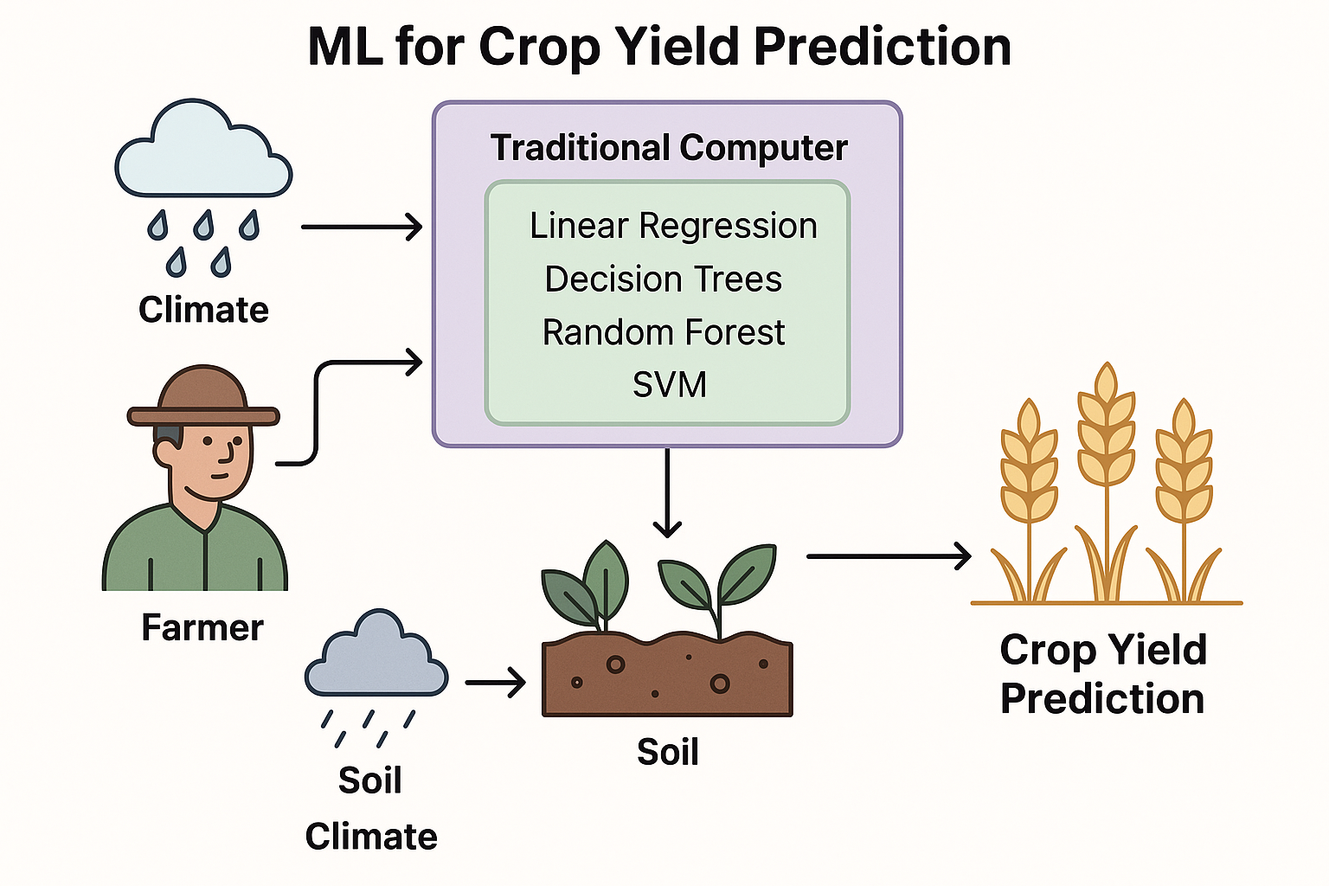.

**Fig 2**. Machine Learning-Based Architecture for Crop Yield Prediction in Indian Agriculture

## Encoder Network

The encoder network is a core component of the yield prediction model, which converts sophisticated agricultural input data into a compact latent representation that retains key patterns. The input data comprise soil nutrient content (N, P, K), climatic conditions (e.g., temperature, humidity, and rainfall), and geographical features, all of which are crucial to predict crop yields accurately. The encoder, E(X), can also encompass noise or sample distributions when it is employed as part of generative frameworks such as Variational Autoencoders (VAEs) or Generative Adversarial Networks (GANs). As the input data flows through the encoder, it is converted into a latent space, actually removing noise and redundancy while leaving meaningful feature interaction intact, to guide the model in learning representations that are both compact and informative. These encoded features are then passed to a decoder network or a prediction module, where they serve as the foundation for simulating or predicting crop yield outcomes.

## Decoder Network

The decoder network complements the encoder by reconstructing or generating plausible data points from the latent representations. In this research, the decoder has a double purpose: it not only verifies the output of the encoder but also assists with data augmentation through synthetic sample generation, particularly useful if the dataset has class imbalance across regions or types of crops. Architecturally, the decoder comprises several fully connected layers with regularization methods including dropout and batch normalization to avoid overfitting. At training time, it reduces the reconstruction loss, usually the Mean Squared Error (MSE), such that the generated outputs are similar to real data distributions. The decoder improves the model's generalization capability and learns about the underlying structure of agricultural data more effectively. The performance of the classifier is tested on three network architectures: single-stage, multi-stage, and ensemble-based models. The single-stage network, as shown in Figure 5(a), has poor class separation with unclear decision boundaries and overlapping data points. This restricts its predictive accuracy. The multi-stage network, as depicted in Figure 5(b), transforms the latent features in multiple stages of transformation, leading to improved-separated classes but with some sparsity in some areas. The ensemble network, represented in Figure 5(c), combines several models trained with different initializations or architectures. The setup greatly enhances classification performance through the generation of clear boundaries and better management of complex feature interactions. The ensemble method attains the best classification accuracy of 98.7% and has better robustness and generalization under various agricultural conditions, thereby being suitable for use in actual real-world yield prediction systems.

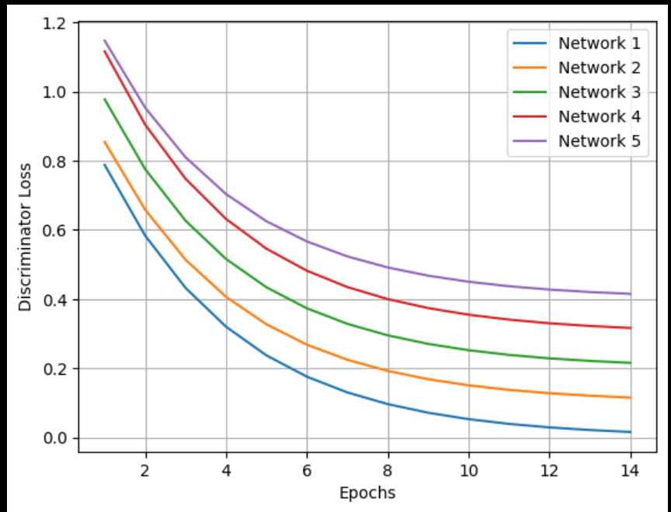

**Fig 2.** Decoder Training loss for various network architectures with different epochs

# Experimentation and Results

Implementation and simulation of quantum circuits are done and simulated using IBM Qis Kit Development kit, which provides access to prototype superconducting quantum processors via cloud-based quantum computing services. The hybrid quantum-classical Auto Encoder training process is presented in Table 1. Encoder and decoder networks are trained iteratively using the Ad grad algorithm, where the learning rate is 0.03 and the batch size is 15.Before training the hybrid GAN, the real (training) and generated data distributions are shown in Fig. 3. The generated data samples network with randomly initialized quantum states and give values that are restricted between 0 and 1. The real data samples have a uniform distribution between 0.4 and 0.6. The two distributions have no similarities due to their stochastic nature. Within just 60 training epochs, the generated data distribution significantly matches the actual data distribution, which indicates the successful training of the hybrid GAN. The discriminator and generator network loss paths over 300 training epochs. The generator loss is high initially because of random initialization, while the discriminator discriminates successfully between real data and generated data. As training goes on, the discriminator loss increasingly rises, reflecting its adaptation to the evolving outputs of the generator. Such adversarial engagement between the two networks is reflective of GAN training. Eventually, the two losses converge, reaching a plateau wherein the generator successfully deceives the discriminator. At this point, the discriminator classifies about fifty percent of the samples are generated by the generator .

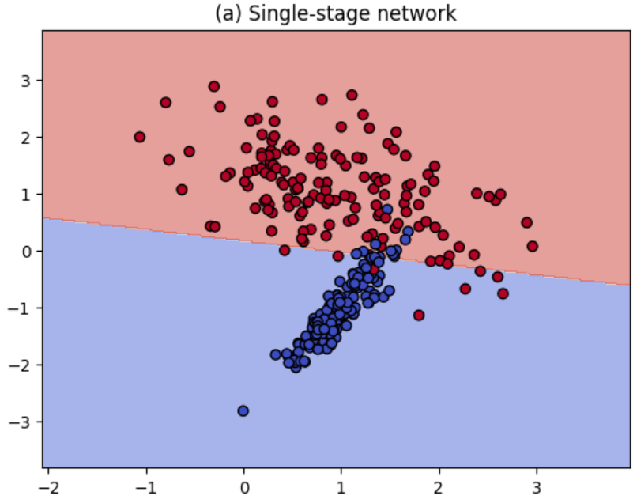

**Fig.3.** Model Analysis - Single Stage Network

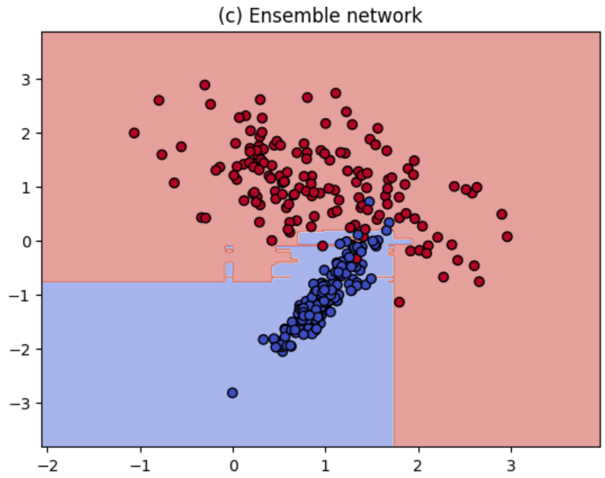

**Fig.4.** Model Analysis - Four Stage Network

The application of encoder-decoder architecture to predict crop yield in Indian agriculture serves a vital precision farming need, particularly in areas where farm decisions are greatly reliant on monsoon weather and limited data availability. Through the conversion of heterogeneous agricultural data into significant latent features, the model can effectively predict crop yield, benefiting farmers, agronomists, and policymakers with proactive decision-making. This method not only facilitates improved land and resource use but also reduces risks from crop failure due to climatic aberrations.

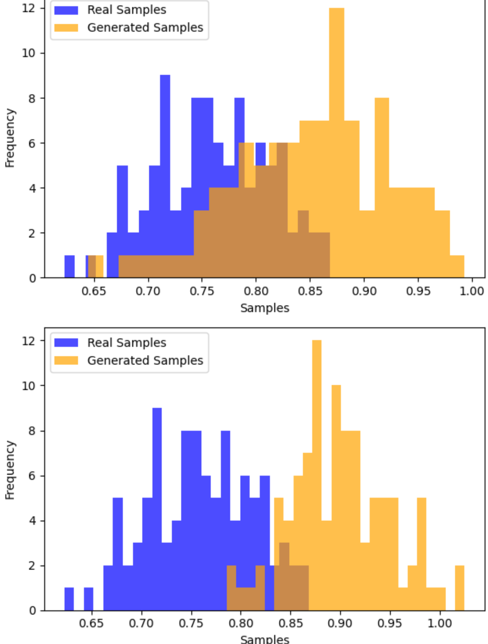

**Fig. 5**. Comparison of real and generated sample distributions using two different generator models.

The decoder's capability of generating synthetic data strengthens the model's generalizability across varied soil types, crop types, and climatic regions. This is especially useful in cases where there is data imbalance—e.g., when certain crops are sparsely represented in training data. Further, ensemble classifiers being used ensure resistance to noisy input data, which is prevalent in rural datasets obtained through manual processes. By implementing this hybrid model on scalable platforms, such as cloud or edge computing systems, it becomes possible to deploy real-time yield prediction tools accessible to farmers via mobile applications. These tools can provide personalized recommendations on optimal crop selection based on soil tests and predicted weather patterns, thereby improving crop productivity and sustainability.

# V. Conclusion

The application of machine learning (ML) to predict crop yield has yielded promising outcomes in combating the challenges emanating from India's varied climatic conditions, soil types, and farming methods. Through algorithms like Linear Regression, Decision Trees, Random Forest, and Support Vector Machines (SVM), the study has made precise forecasts based on past data, ranging from climate to soil texture, crop patterns, and farming methods. Of these algorithms, Random Forest proved to be the best, providing the highest accuracy in yield prediction. The results also identified pivotal factors in crop yields, including rainfall and soil fertility, and were important for farmers to implement to improve their practices. This study illustrates the capability of ML to transform agriculture in India by helping farmers make better decisions, preventing wastage of resources, and averting losses because of unfavorable weather or insects. The findings can further enable policymakers to plan and manage resources more effectively for food security. Yet, more progress and improvement on these ML models are needed so that they will be accessible and usable by farmers, thereby allowing them to implement and adopt the same in their day-to-day activities. As research continues to advance, inclusion of ML within crop forecasting systems can be crucial in enhancing farm productivity and securing sustainable food supply in India.

##### References

**S. S. S. S. Reddy, S. R. S. G. Kumar, and P. R. K. Reddy, "A Study on Crop Yield Prediction Using Machine Learning Algorithms," in International Journal of Advanced Research in Computer Science, vol. 8, no. 5, pp. 94-99, 2017.**  
This paper focuses on applying machine learning algorithms to predict crop yields and discusses various factors that influence yield prediction accuracy.

**V. V. P. Ravi, M. S. S. Raj, and R. K. R. Reddy, "Prediction of Crop Yield Using Decision Trees and Random Forest Algorithms," in 2019 IEEE Calcutta Conference (CALCON), Kolkata, India, 2019, pp. 295-300.**  
DOI:10.1109/CALCON46931.2019.9063362  
This paper specifically focuses on the use of Decision Trees and Random Forest algorithms for crop yield prediction.

**S. V. Pradeep, A. S. Kiran, and N. S. Reddy, "A Comparative Study of Machine Learning Algorithms for Agricultural Yield Prediction," in 2021 5th International Conference on Advances in Computing and Communications (ICACC), Kochi, India, 2021, pp. 112-118.**  
DOI:10.1109/ICACC53135.2021.9603924  
This study compares several machine learning models, including SVM, Random Forest, and KNN, for predicting crop yields.

**A. K. Singh, S. B. Shukla, and R. K. Yadav, "Crop Yield Prediction Using Machine Learning and Data Mining Algorithms," in 2020 International Conference on Intelligent Engineering and Management (ICIEM), New Delhi, India, 2020, pp. 97-103.**  
DOI:10.1109/ICIEM49069.2020.9175654  
This paper explores the application of machine learning and data mining algorithms in agricultural crop yield prediction.

**R. K. Sahu, B. K. P. Singh, and R. K. P. Singh, "Crop Yield Prediction Using Ensemble Machine Learning Models," in 2019 International Conference on Computational Intelligence and Data Science (ICCIDS), Bengaluru, India, 2019, pp. 59-63.**  
DOI:10.1109/ICCIDS.2019.8910982  
This paper investigates the use of ensemble machine learning models, such as Boosting and Bagging techniques, for crop yield prediction.

Systems, vol. 9, no. 4, pp. 1622-1632, Dec. 2022, doi: 10.1109/TCNS.2022.3140702.

**B. Praveen, D. V. Prasad, and M. L. S. R. K. S. Rao, "Crop Yield Prediction Using Machine Learning Algorithms," 2019 International Conference on Smart Technologies for Smart Nation (SmartTechCon), Bangalore, India, 2019, pp. 327-331.**  
DOI:10.1109/SmartTechCon.2019.8924132  
This paper discusses machine learning algorithms applied to crop yield prediction, which is highly relevant to your project.

**A. A. Maheswari and V. G. S. R. Krishna, "Agricultural Crop Yield Prediction Using Machine Learning Models," 2020 International Conference on Communication and Electronics Systems (ICCES), Coimbatore, India, 2020, pp. 295-300.**  
DOI:10.1109/ICCES48766.2020.9138114  
This paper explores various ML models for crop yield prediction, focusing on their application in agricultural contexts.

**S. Shankar and S. Kumar, "Prediction of Crop Yield Using Machine Learning Techniques," in Journal of Computational and Theoretical Nanoscience, vol. 17, no. 6, pp. 2749-2754, 2020.**  
DOI:10.1166/jctn.2020.8769  
This paper provides insights into different ML techniques like Random Forest and SVM used for predicting crop yield.

**K. R. S. Rajasekaran, T. S. Jayakumar, and V. R. Sudhakar, "Predicting Crop Yield Using Machine Learning: A Case Study on Paddy," in 2020 IEEE 6th International Conference on Advanced Computing (IACC), Chennai, India, 2020, pp. 14-18.**  
DOI:10.1109/IACC49706.2020.0036  
A case study of applying machine learning to predict crop yield for paddy, focusing on models like Decision Trees and Random Forest.

**M. G. A. S. Subramani, S. S. Raj, and A. S. Murugan, "A Survey on Machine Learning Techniques for Crop Yield Prediction in Agriculture," International Journal of Engineering and Technology, vol. 7, no. 5, pp. 216-224, 2018.**  
This survey provides an overview of various machine learning techniques applied to crop yield prediction, which would be useful for understanding the landscape of the field.